**Program to Input Marks of Students in Array and Print largest Number.**

#include<stdio.h>

#include<conio.h>

void main()

{

int n, marks[99], l=0, i ;

printf("Enter the number of Students in Class (100 MAX): ");

scanf("%d",&n);

for(i=0;i<n;i++){

printf("Enter Student %d marks: ",i+1);

scanf("%d",&marks[i]);

if(l<marks[i]) l=marks[i];

}

printf("Highest Marks: %d",l);

getch();

}

**Output:**

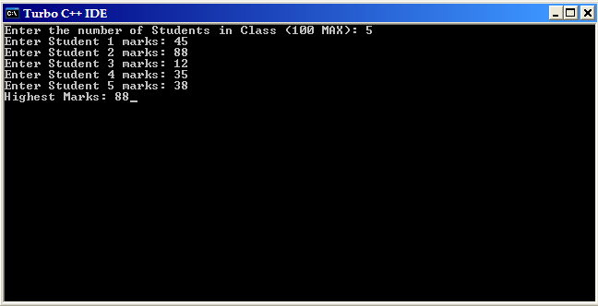

**Program to convert Binary number to Decimal Number.**

#include <stdio.h>

#include<conio.h>

#include <math.h>

void main()

{

int i=0, bin, swap, dec=0, temp;

printf("Enter any Binary No. to convert it to Decimal: ");

scanf("%d",&bin);

temp=bin;

while( bin!=0 ){

swap = bin%10;

bin /= 10;

dec += swap*pow(2,i);

i++;

}

printf("%d in Decimal is %d.",temp,dec);

getch();

}

**Output:**

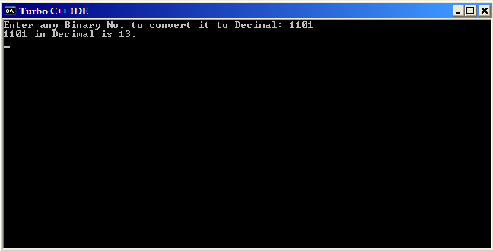

**Program to find all Possible Factors of a given positive integer.**

#include <stdio.h>

#include <conio.h>

void main()

{

int number, i;

clrscr();

printf("Enter a positive integer: ");

scanf("%d",&number);

printf("Factors of %d are: ", number);

for(i=1; i <= number; ++i)

{

if (number%i == 0)

{

printf(" %d ",i);

}

}

getch();

}

**Output:**

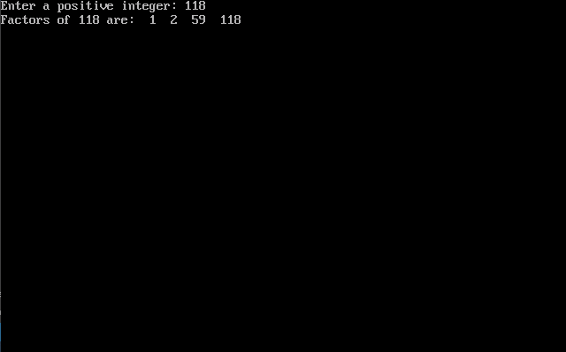

**Program to Check whether a Year is Leap Year or Not.**

#include <stdio.h>

#include <conio.h>

void main()

{

int year;

clrscr();

printf("Enter the year: ");

scanf("%d" ,&year);

if ( year%4==0 )

{

printf("\n%d is a Leap year." ,year);

}

else

{

printf("\n%d is not a Leap year." ,year);

}

getch();

}

**Output:**

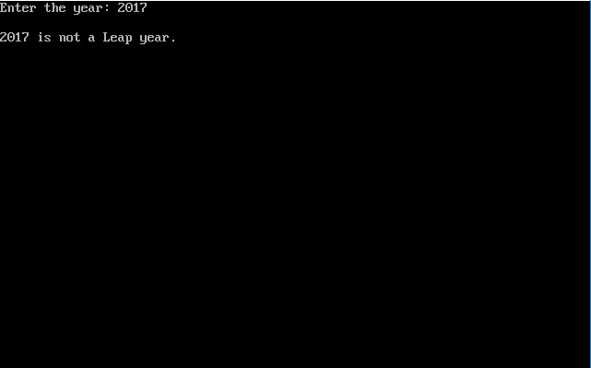

**Program to find sum of first N Numbers.**

#include <stdio.h>

#include <conio.h>

void main()

{

int i, num, sum = 0;

clrscr();

printf("Enter a number to find sum upto: ");

scanf ("%d", &num);

for (i = 1; i <= num; i++)

{

sum += i;

}

printf ("Sum of first %d natural numbers = %d\n", num, sum);

getch();

}

**Output:**

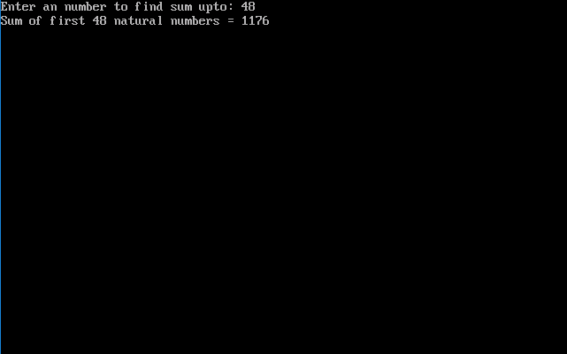

**Program to Find out Pass & Failed number of Students by inputting their Marks.**

#include<stdio.h>

#include<conio.h>

void main()

{

int st, pass=0, fail=0, num;

printf("Enter total number of Students: ");

scanf("%d",&st);

for(int i = 1; i <= st; i++)

{

again:

printf("Enter Student %d marks (Out of 100): ",i);

scanf("%d",&num);

if(num<=100){

if(num>=40) pass++;

else if(num<40) fail++;

}else {

printf("Total Marks Can't be greater than 100 !!!\n");

goto again; }

}

printf("Your class has %d pass & %d fail students.\n",pass,fail);

getch();

}

**Output:**

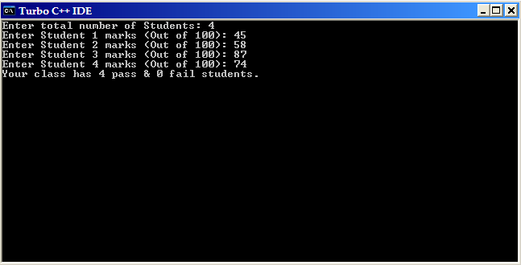

**Program to get Fibonacci series up to Nth term.**

#include <stdio.h>

#include <conio.h>

void main()

{

int i, n, t1 = 0, t2 = 1, nextTerm;

clrscr();

printf("Enter the number of terms: ");

scanf("%d", &n);

printf("Fibonacci Series: ");

for (i = 1; i <= n; ++i)

{

printf("\n%d", t1);

nextTerm = t1 + t2;

t1 = t2;

t2 = nextTerm;

}

getch();

}

**Output:**

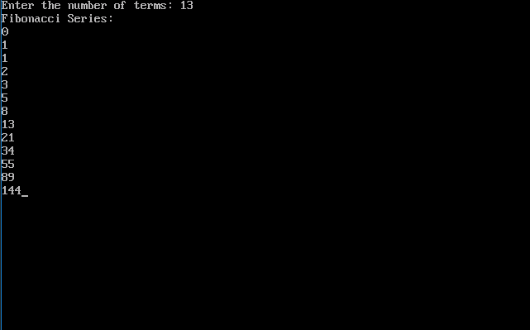

**Program to print Triangle Star pattern.**

#include<stdio.h>

#include<conio.h>

void main()

{

for(int i=1;i<=5;i++){

for(int j=i;j<5;j++){

printf(" ");

}

for(int k=1;k<=(2*i-1);k++){

printf("*");

}printf("\n");

}

getch();

}

**Output:**

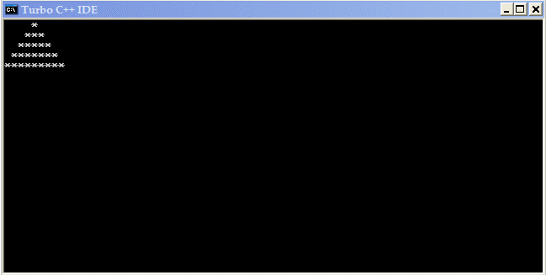

**Program to print Multiplication Table from 1 to 10.**

#include<stdio.h>

#include<conio.h>

void main()

{

for(int i=1 ; i<=10 ; i++){

for(int j=1 ; j<=10 ; j++){

printf("%d\t",i*j);

}

printf("\n");

}

getch();

}

**Output:**

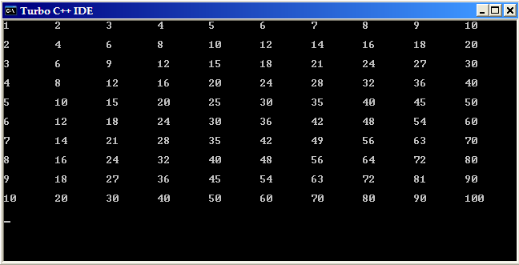

**Program to Find Repetitive or Complex Sum of Number.**

#include<stdio.h>

#include<conio.h>

void main()

{

int swap=0, num, sum=0;

printf("Enter a No. to find Complex sum of: ");

scanf("%d", &num);

while(num!=0){

swap=num%10;

num/=10;

sum+=swap;

}

while(sum>0){

swap=sum%10;

sum/=10;

num+=swap;

}

printf("Sum = %d\n",num);

getch();

}

**Output:**

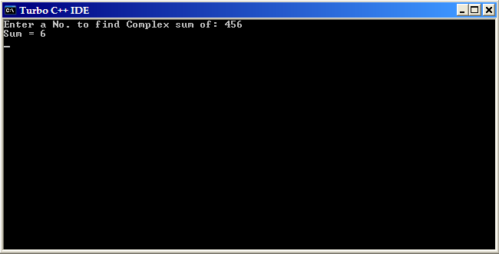

**Program of Simple Calculator using Switch.**

#include<stdio.h>

#include<conio.h>

void main()

{

float small,large,res; char ch;

do{

printf("Enter two Numbers: \n");

scanf("%f%f",&large,&small);

}

again:

printf("Select operator: {+}{-}{*}{/} ");

ch=getch();

printf("%c",ch);

switch(ch){

case '+':

{

res=large+small;

break;

}

case '-':

{

res=large-small;

break;

}

case '*':

{

res=small*large;

break;

}

case '/':

{

res=large/small;

break;

}

default:

{

printf("\n!!! Wrong Choice !!!\n");

goto again;

break;

}

}

printf("\n%.2f %c %.2f is %f",large,ch,small,res);

printf("\nDo You want to Calculate again ? (Y/N)\n");

ch=getch();

clrscr();

}while(ch=='Y'||ch=='y');

getch();

}

**Output:**

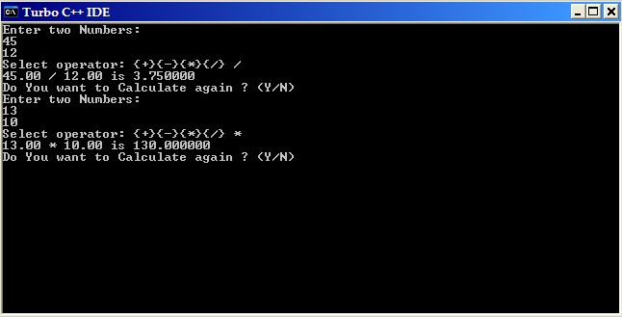

**Program to find total Number of Male & Female Voters By getting their Age and Gender as Input.**

#include<stdio.h>

#include<conio.h>

void main()

{

int nvot, age, male=0, female=0, voter=0, pop;

char gen;

printf("Enter Total Population: ");

scanf("%d",&pop);

for(int i = 1; i <= pop; i++)

{

printf("Enter age of Person %d: ",i);

scanf("%d",&age);

if (age>=18) voter++;

again:

printf("Enter Person %d gender (M/F): ",i);

gen=getch();

printf("%c\n",gen);

if (gen=='M'||gen=='m'){

if(age>=18) male++ ;

else continue;

}

else if (gen=='F'||gen=='f'){

if(age>=18) female++ ;

else continue;

}

else {

printf("Are you sure this is an option?\nTry Again!!!\n");

goto again;

}

}

nvot=pop-voter;

printf("\nYou got total %d voters, out of which %d are male & %d are female & %d persons can't vote as they are underage.\n",voter, male, female, nvot);

getch();

}

**Output:**

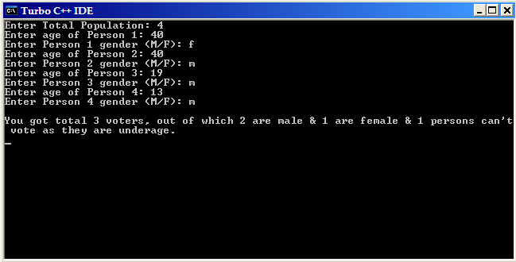

**Program to Find out whether a Number is Prime or Not.**

#include <stdio.h>

#include<conio.h>

void main()

{

int n, i, flag = 0;

printf("Enter a positive integer: ");

scanf("%d", &n);

for(i = 2; i <= n/2; i++)

{

if(n%i==0) {

flag = 1;

break; }

} if (n == 1)

printf("1 is neither a prime nor a composite number.");

else {

if (flag == 0)

printf("%d is a prime number.", n);

else

printf("%d is not a prime number.", n);

}

getch();

}

**Output:**

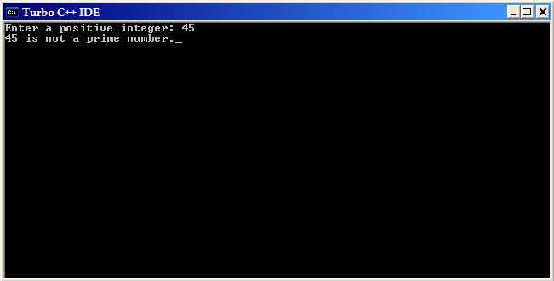

**Program to Find Reverse of a Number & check whether it’s Palindrome or Not.**

#include<stdio.h>

#include<conio.h>

void main()

{

int num,rev=0,d,c=0,sum=0,temp;

printf("Enter any Number: ");

scanf("%d",&num);

temp=num;

while(num>0){

d=num%10;

num=num/10;

rev=(rev*10)+d;

}

printf("Your Number Reversed is: %d",rev);

printf("\nYour Digit Sum is %d containing %d digits.",sum,c);

if (temp==rev) printf("\nYour Number is a Palindrome.");

getch();

}

**Output:**

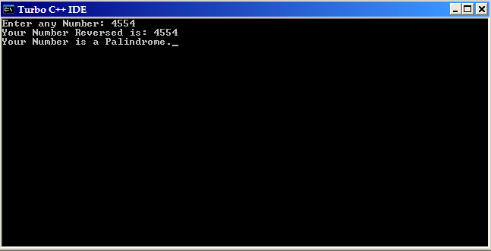

**Program to Find Discount & Net Amount by Total Purchase Amt.**

#include<stdio.h>

#include<conio.h>

void main()

{

float pAmt,disc,net;

printf("Enter Purchase Amt: ");

scanf("%f",&pAmt);

if(pAmt<500){

disc=0;

net=pAmt;

} else if(pAmt>=500 && pAmt<1000){

disc=0.05*pAmt;

net=pAmt-disc;

} else if(pAmt>=1000 && pAmt<2000){

disc=0.07*pAmt;

net=pAmt-disc;

} else {

disc=0.1*pAmt;

net=pAmt-disc;

}

printf("Congrats!!! You got Rs.%.2f Disc. & Net Payable Amt is %.2f",disc,net);

getch();

}

**Output:**

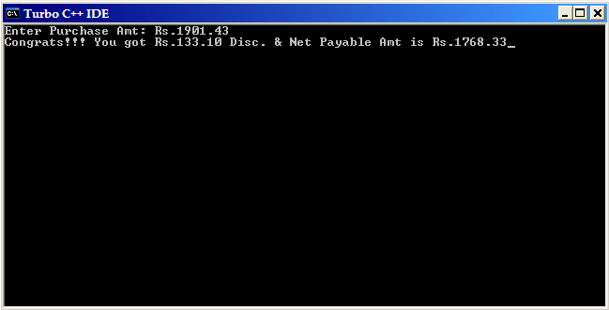

**Program to sort Elements of An Array using Selection Sort.**

#include<stdio.h>

#include<conio.h>

void main()

{

int a[100],i,n,t;

printf("Enter number of elements: ");

scanf("%d",&n);

for(i=0;i<n;i++){

printf("Enter Element %d: ",i+1);

scanf("%d",&a[i]);

} for(i=0;i<n-1;i++){

for(int j=i+1;j<n;j++){

if(a[i]>a[j]){

t=a[i];

a[i]=a[j];

a[j]=t;}

} }

printf("Sorted Elements: ");

for(i=0;i<n;i++){

printf("%d ",a[i]);

}

getch();

}

**Output:**

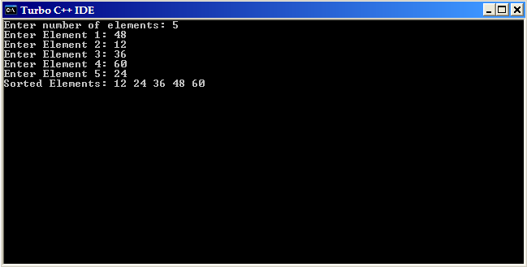

**Program to find Factorial of a given positive integer.**

#include <stdio.h>

#include <conio.h>

void main()

{

int i, n;

unsigned long long fact=1;

clrscr();

printf("Enter an Positive Integer to find Factorial of: ");

scanf("%d" ,&n);

if ( n<0 )

printf("\nError! You Entered a Negative Value");

else

{

for (i = 1; i <= n; ++i)

{

fact *= i;

}

printf("\nFactorial of %d is %llu" ,n ,fact);

}

getch();

}

**Output:**

